# Project assessment

## Criteria

### Social Media Module

Cl Basic Web

ICTWEB304 - Build simple web pages (1)

ICTWEB305 - Produce digital images for the web (1)

### Qualification/Course code and name

ICT30120 | Certificate III in Information Technology (2)

## Student details

### Student number

881674614

### Student name

Ting Hu

## Assessment declaration

*Note: If you are an online student, you will be required to complete this declaration on the TAFE NSW online learning platform when you upload your assessment.*

This assessment is my original work and has not been:

* plagiarised or copied from any source without providing due acknowledgement.
* written for me by any other person except where such collaboration has been authorised by the Teacher/Assessor concerned.

### Student signature and date

Ting Hu 23/06/2025

Version: *20220809*

Date created: *19 August 2021*

Date modified: *27 June 2025*

For queries, please contact:

*Technology and Business Services*

*Ultimo*

© 2022 TAFE NSW  
RTO Provider Number 90003 | CRICOS Provider Code: 00591E

This assessment can be found in the: [Learning Bank](https://share.tafensw.edu.au/share/access/searching.do?doc=%3Cxml%2F%3E&in=P7ac4831b-430a-4b8d-8b56-f7b32ed5b9cf&q=&type=standard&sort=rank&dr=AFTER)

The contents in this document is copyright © TAFE NSW 2022 and should not be reproduced without the permission of TAFE NSW. Information contained in this document is correct at the time of printing: 27 June 2025. For current information please refer to our website or your Teacher/Assessor as appropriate.

## Assessment instructions

Table 1 Assessment instructions

| Assessment details | Instructions |
| --- | --- |
| **Assessment overview** | The aim of this assessment is to assess your knowledge and performance in using an integrated development environment (IDE) to create, modify and test, simple web pages and web content, according to client requirements. |
| **Assessment event number** | 2 of 2 |
| **Instructions for this assessment** | This is a project-based assessment that assesses your knowledge and performance of the unit.  This assessment is in five parts:   1. Plan the website 2. Manipulate and save images 3. Set up the website 4. Build the website 5. Upload, test and finalise the website.   And is supported by:   * Assessment Checklists 1, 2 * Observation Checklist * Supporting documents contained in Cl_BasicWeb_AE_Pro_Appx.zip.   **Note**: This assessment may contain links to external resources. If a link does not work, copy and paste the URL directly into your browser. |
| **Submission instructions** | On completion of this assessment, you are required to submit it to your Teacher/Assessor for marking. Where possible, submission and upload of all required assessment files should be via the TAFE NSW online learning platform.  It is important that you keep a copy of all electronic and hardcopy assessments submitted to TAFE and complete the assessment declaration when submitting the assessment. |
| **What do I need to do to achieve a satisfactory result?** | To achieve a satisfactory result for this assessment you must answer all the questions correctly.  If a resit is required to achieve a satisfactory result it will be conducted at an agreed time after a suitable revision period. |
| **What do I need to provide?** | * TAFE NSW student account username and password. If you do not know your username and password, contact your campus or service centre on 131601. * Computer or other device with word processing software and internet access * Writing materials, if required * Storage media.   If assessment is completed off campus:   * Integrated development environment (such as Adobe Dreamweaver) * FTP client software * Image manipulation software (such as Adobe Photoshop) * To host your website you can use a hosting service like Microsoft Azure or a free web hosting service such as [InfinityFree](https://share.tafensw.edu.au/share/items/9b075f3e-20d0-4707-b451-f282482625df/0/?attachment.uuid=69372eae-0e75-481c-b769-784d8e189506), [BYET Internet Services](https://share.tafensw.edu.au/share/items/9b075f3e-20d0-4707-b451-f282482625df/0/?attachment.uuid=7a1fa0bb-044c-48b7-b8b4-1e0142fd1d19), or [000webhost](https://share.tafensw.edu.au/share/items/9b075f3e-20d0-4707-b451-f282482625df/0/?attachment.uuid=83162643-50ac-4283-a1d0-ae9c5e8af05e). |
| **What the Teacher/Assessor will provide** | Access to the learning management systems.   * Integrated development environment (such as Adobe Dreamweaver) * FTP client software * Image manipulation software (such as Adobe Photoshop) * If an on-campus web server is available, passwords and access procedures to access the web server * Files contained within Cl_BasicWeb_AE_Pro_Appx.zip including:   + Client website specifications   + Images. |
| **Due date**  **Time allowed**  **Location** | Indicative time to complete assessment:   * In class: Three hours * Out of class: Four hours   This assessment will be completed both in and outside of the classroom.  The student may access their referenced text, learning notes and other resources.  If you are unable to verify the authenticity of the student’s submission you will need to gather additional evidence to confirm that the assessment task was completed by the student. This may include oral questioning, comparison with in-class work samples, or observation. |
| **Assessment feedback, review or appeals** | In accordance with the TAFE NSW policy *Manage Assessment Appeals,* all students have the right to appeal an assessment decision in relation to how the assessment was conducted and the outcome of the assessment. Appeals must be lodged within **14 working days** of the formal notification of the result of the assessment.  If you would like to request a review of your results or if you have any concerns about your results, contact your Teacher/Assessor or Head Teacher. If they are unavailable, contact the Student Administration Officer.  Contact your Head Teacher/Assessor for the assessment appeals procedures at your college/campus. |

## Specific task instructions

The instructions and the criteria in the tasks and activities will be used by your Teacher/Assessor to determine if you have satisfactorily completed this assessment event. Use these instructions as a guide to ensure you demonstrate the required knowledge and skills.

### Scenario

A local cake shop, Special Cakes for All Occasions,has approached Gelos Enterprises (GE) to build their website, including producing digital images for the website. As an Information Technology Trainee working for Gelos, you have been assigned the task to build the website using an integrated development environment (IDE).

Sam Rice, the owner of Special Cakes for All Occasions, wants to use the website to promote their products. In addition, they do not want to maintain the website themselves and has asked Gelos to maintain it.

Your Gelos supervisor for this task is Vinh Nguyen, the Web Development Team Leader. They have supplied you with the client requirements for the website, as outlined in the website specification brief (SpecialCakesWebsiteSpecifications.docx), as well as a CSS file (specialcakesstyles.css) containing suitable styles for the website.

Download and unzip the [resource folder](https://share.tafensw.edu.au/share/items/cf3540af-783f-4d19-9920-bb83226f2099/0/?attachment.uuid=2e28f3e1-055a-4128-9107-9702d0d54375) (Cl_BasicWeb_AE_Pro_Appx.zip), which contains the specifications for the website and other documents you will need in this assessment.

You will need access to a web server to upload the website. You can use a hosting service like Microsoft Azure or a free web hosting service such as [InfinityFree](https://share.tafensw.edu.au/share/items/9b075f3e-20d0-4707-b451-f282482625df/0/?attachment.uuid=69372eae-0e75-481c-b769-784d8e189506), [BYET Internet Services](https://share.tafensw.edu.au/share/items/9b075f3e-20d0-4707-b451-f282482625df/0/?attachment.uuid=7a1fa0bb-044c-48b7-b8b4-1e0142fd1d19), or [000webhost](https://share.tafensw.edu.au/share/items/9b075f3e-20d0-4707-b451-f282482625df/0/?attachment.uuid=83162643-50ac-4283-a1d0-ae9c5e8af05e).

## Part 1: Plan the website

Access and analyse the web specifications brief (SpecialCakesWebsiteSpecifications.docx) to determine the client requirements, as well as identify and plan your tasks for the project.

### Task 1

Use the Client Requirements Analysis template from the [resource folder](https://share.tafensw.edu.au/share/items/cf3540af-783f-4d19-9920-bb83226f2099/0/?attachment.uuid=2e28f3e1-055a-4128-9107-9702d0d54375) (Cl_BasicWeb_AE_Pro_Appx.zip), to write a requirements analysis report for the client (approximately 450-600 words).

Your analysis must include the following points:

1. Summary of the client’s requirements for the website which you should determine from the information provided. This must include:
   * Content
   * Style requirements including specific colours and any specifics about the logo
   * Size of the required images.

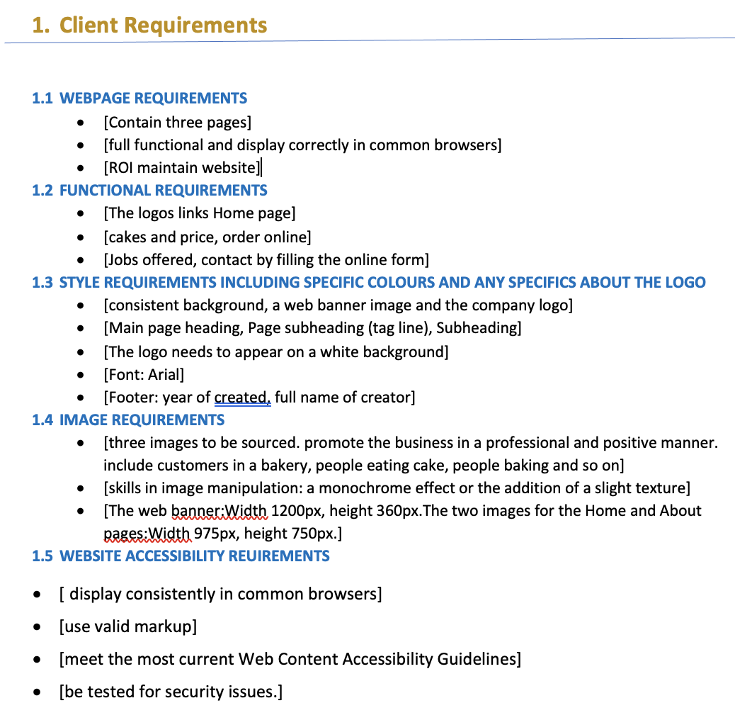

The website needs the following pages:

1. Home page
2. About page
3. Sales page
4. Contact page

The website must use the to lowing company so colours.

1. Burnt red and navy blue.
2. Images must be provided in a few different sizes for example small and large images for the cakes and the logo needs to be in PNG format and a hero image need to be in very high quality.
3. I Ned will be maintaining the site and I will be hosted on git hup for now because it is a very hosting
4. Logo must appear on white background in the top left of the header.
5. The footer should show the year the website was created and your full name
6. The hero must be fullwidth of the container with max height 400px
7. Visit one or some of the following websites [Freepik](https://www.freepik.com/), [Pexels](https://www.pexels.com/) or [Unsplash](https://unsplash.com/) to source and access three appropriate images that follow organisational requirements on sourcing images. Ensure you meet copyright standards when choosing your images. For each image:
   * list the name of the website and the URL from where it was obtained

The business requires three images. A hero image and some icons for social media. We also used images of bakery, people eating cake and people baking cake.

https://unsplash.com/

* + explain how it meets the requirements and copyright standards and legislation

It’s free to download, and all images can be downloaded and used for personal or commercial projects.

* + include a screenshot of its licensing restrictions.

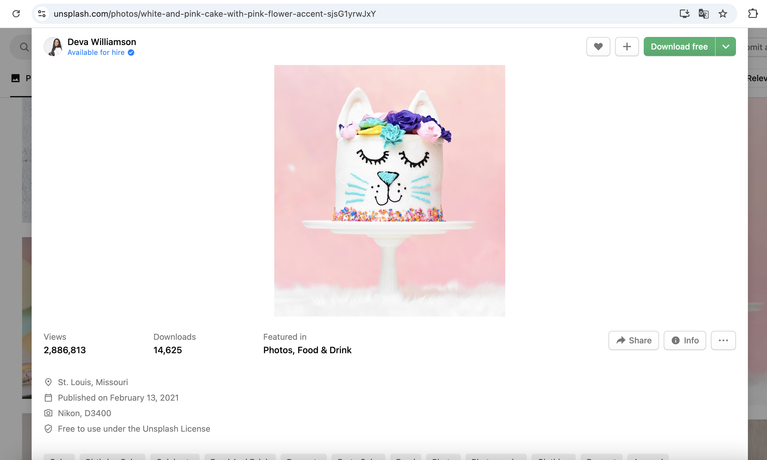

1. Describe the purpose and specific functions of each of the following types of digital systems and tools used in building websites (100-200 words) (copy the following table into your report).

Table 2 Digital system/tool

|  |  |  |
| --- | --- | --- |
| Type of digital system/ tool | Purpose | Specific functions |
| Integrated development environment (IDE) | provides comprehensive facilities to computer programmers for software development. | It combines various tools necessary for coding, testing, and debugging into a single, user-friendly interface. |
| Image editing software | Editing the images | Make effects on the images |
| File transfer protocol (FTP) software | upload, download, and manage files on remote servers. | transfer files between computers over a network |
| Browser | to access and display information from the internet, acting as a user interface for navigating the World Wide Web | allows you to browse the internet and interact with websites. |

1. Use the internet to research three common systems and tools in each of the following categories. For each system or tool, describe at least two features of the system or tool.  (Copy the following table into your report).

Categories:

* Integrated Development Environment (IDE)
* Image software
* File Transfer Protocol (FTP)
* Internet Browsers

Table 3 Digital system/tool

| Type of digital system/ tool | Name of common digital system/ tool | Key features |
| --- | --- | --- |
| Integrated Development Environment (IDE) 1 | Dreamweaver | Adobe Dreamweaver comes with templates, CSS styles, layouts, server-side scripting and database support, themes and inbuilt Site and FTP Management. Cost not cheap. |
| Integrated Development Environment (IDE) 2 | Visual Studio code | Visual Studio is an Integrated Development Environment (IDE) available from Microsoft, with a free community version. It also includes a website editor and designer that allow web pages to be authored by dragging and dropping widgets. Free. |
| Integrated Development Environment (IDE) 3 | [IntelliJ IDEA](https://www.google.com/search?sca_esv=6d6d50e00e08b0cb&rlz=1C5MACD_enAU1103AU1103&cs=0&sxsrf=AE3TifO4vQY4SBjP543keOsp15kb3aFHNA%3A1750681000242&q=IntelliJ+IDEA&sa=X&ved=2ahUKEwjHqez4woeOAxUeh68BHXvHDhAQxccNegQIWBAB&mstk=AUtExfDlXAsaFj5QSE-Qm7Mt8lvsX_KtLv6Ymw6ootGkZDedH4K0jncUmdp3FyeUsFj3mJYCbcaiT13lTUMiKzTwJ28FM5HuAVy8SBdf9BLUbM1UbzsNBVlxmDaKrxVkjyLyJS_AvdYMLlnQeIjQxQ549e34eGmv5uy42VkEKeR14hbw7CCWCZxISg9CyDiv-eVXjP-w-5ENT23ShOlxZs6kuKAoXxxclDq_VhoMeQgYR36EQI7vDhvy6HtBTRHKqiq99Hxl-UNjYrWZzQjzkSqm38nc&csui=3) | A powerful IDE for Java and other languages, known for its intelligent code completion and refactoring capabilities. |
| Image editing software 1 | Adob​​e Photoshop | industry-standard professional software, expensive . |
| Image editing software 2 | Illustrator | industry-standard professional software , expensive . |
| Image editing software 3 | [GIMP](https://www.gimp.org/)/  [Pixlr](https://pixlr.com/editor/) | on-professional , little or no cost. |
| File Transfer Protocol (FTP )1 | WinSCP | Popular among Windows users |
| File Transfer Protocol (FTP )2 | **Cyberduck** | Widely used by both beginners and advanced users. Windows, Mac. |
| File Transfer Protocol (FTP )3 | Transmit | Favored by Mac users, especially web developers. Mac. |
| Browser 1 | Google chrome | One of the most widely used web browsers (often simply referred to as Chrome). Chrome is a web browser developed by Google. |
| Browser 2 | Safari | Safari is a web browser that comes pre-installed on Apple products. On your device, you'll use it to access websites. Safari has a user interface that is comparable to that of a desktop web browser. |
| Browser 3 | **Microsoft Edge** | Included with Windows, unlike other browsers that must be downloaded. That means that if you have a Windows computer, you already have Edge (or Explorer). |

1. Select an Integrated Development Environment (IDE) that you will use to create the website and explain how this IDE will meet the requirements of the client.

Visual Studio: Visual Studio is an Integrated Development Environment (IDE) available from Microsoft, with a free community version. It also includes a website editor and designer that allow web pages to be authored by dragging and dropping widgets. It’s free.

1. Select an industry-standard image editing software application that you will use to edit the required images for the website and explain why this software is applicable for this project.

Photoshop. It is a powerful tool used by professionals in various creative fields for tasks ranging from basic retouching to complex photo manipulation and graphic design. While Photoshop excels in raster graphics and detailed image manipulation, [Adobe Lightroom](https://www.google.com/search?sca_esv=de7b93cea84487c6&rlz=1C5MACD_enAU1103AU1103&cs=0&sxsrf=AE3TifOXukcTs2jL-75xDyfysWsnt-x9lA%3A1750681997826&q=Adobe+Lightroom&sa=X&ved=2ahUKEwiN57_UxoeOAxWGglYBHS3CMSwQxccNegQICBAB&mstk=AUtExfB6SIbULO8Z2slHMVVNT0SULMNwd-QsYsZ8vsNDZymkOuG-hLjwGfRTe6vGoC5IdKR1IK6QkPPT42hvbpUn4DKHtQYtRj3JecVdmF85i5UEYeOTlQbAg24mLoWBrS1U0Uw6EFMRVCGRo9V4lZyKQQ2nrRHoXl1yOPk60Blvtg0BOiS6ResXO3GNMFCTIzUWib-mvMu0OwdUwmkRsVdjlo8hKv7RcJ3Lvg-tS1vW4e-cBlpsEtqm8FH9HCcQ8vdXTr6HhgD2Oed3kdploznR8hMW&csui=3) is often used alongside it for photo organization, raw processing, and color grading.

1. Plan the navigation of the website by building a suitable sitemap showing the web pages and how they are linked to each other.

1. Use the [Task planner template](https://share.tafensw.edu.au/share/items/cf3540af-783f-4d19-9920-bb83226f2099/0/?attachment.uuid=2e28f3e1-055a-4128-9107-9702d0d54375) (GE_TaskPlanner-template.docx) to identify and plan your role and responsibilities within this website project. Include a list of ordered and prioritised tasks in your workload.

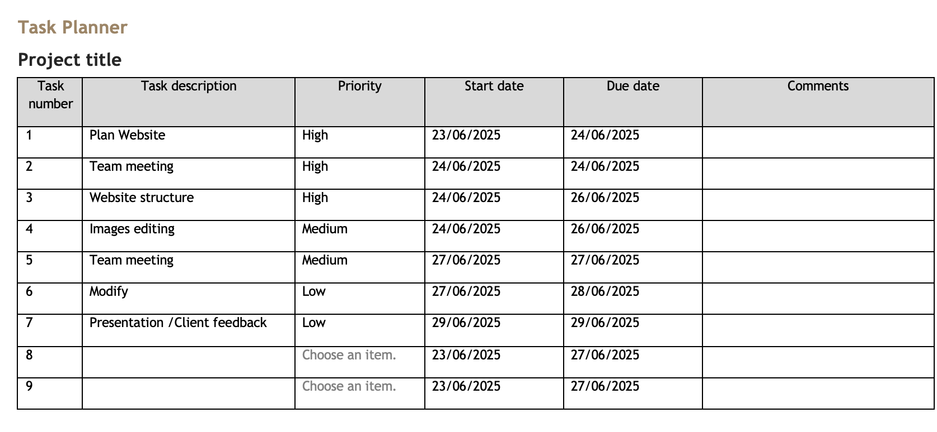

### Task 2

1. When you have completed your report, write an email to your supervisor and the client using the [GE email template](https://share.tafensw.edu.au/share/items/02285ff1-cfb2-4af4-b402-fdc23bf4bf11/0/?attachment.uuid=2a6ed3d4-ca14-427f-8583-ceb6bcb08c1b) to submit the report.

1. You will need to confirm the following items from your report with your supervisor:
   1. Your own role and responsibilities
   2. The use of the IDE that you have selected
   3. The purpose, functions and features of common digital systems and tools.

Discuss these (in person or writing) with another person acting as your supervisor. The other person could be a colleague, industry expert/representative or your teacher.

You will need to obtain and submit their confirmation as evidence. This may be in one of various forms such as a reply email or sign-off on your report.

My role at Gelos is a web design developer currently working on Special Cakes for All Occasions website. I have selected to use VS Code as the preferred IDE due to the large volume of extension and support available.

## Submit Part 1

Submit the following:

* Requirements Analysis Report
* Task planner
* Email to supervisor and client
* Evidence of confirmation from supervisor

## Part 2: Manipulate and save images

Refer to Assessment Checklist 1 for the marking criteria for this part.

Using the industry-standard image editing software application that you previously selected, manipulate and save the three images you have sourced (in Part 1.2) as follows. Make sure that you follow the copyright standards and legislation for the images, as you outlined in Part 1 Task 1.2.

1. Before you start, make backups of the original images in a folder named “original_images”*.*
2. For each image you have sourced, edit it to:
   1. improve the image – this may include adjusting lighting and colour, or removing unwanted content
   2. resize to the required dimensions (including cropping where necessary), without distorting the image.
3. Create a range of effects on the images, appropriate to the client requirements.
4. Save the edited images in a folder named “modified_images”*,* ensuring that:
   1. you use the default file format of the image editing software with all layers intact (where appropriate), e.g., PSD for Photoshop files
   2. they are named according to the client requirements.
5. Save each image again, in a folder named “web_images”, so that it can be used in a website. For each image, ensure that:
   1. you use the most appropriate file format
   2. it is named according to the client requirements.

Zip the image folders into one file to submit.

## Submit Part 2

Submit the following:

* A zipped folder containing:
  + a folder of your original images
  + a folder of modified images
  + a folder of web images

## Part 3: Set up the website

Use your selected IDE to set up the website according to the website specifications. If you have been provided with access to an on-campus web server, use the provided passwords and access procedure. Otherwise, create a secure password to access your web server.

### Task 1

Set the preferences for the IDE that you are using, demonstrating two different settings. Include preferences for the:

* + correct directory structure and location (where your website files will be stored)
  + file transfer protocol (FTP) settings.

Take screenshots of this task and place in the box below.

Task 2

Refer to the Observation Checklist for the marking criteria for this part.

The following tasks will be observed by your Teacher/Assessor or can be digitally recorded and submitted as evidence.

If you are submitting video evidence, you must:

* provide a video clearly meeting all requirements listed below
* ensure you have access to the equipment and resources required to participate in the demonstration
* follow the [Video recording instructions (pdf)](https://share.tafensw.edu.au/share/items/744af7d4-a241-45e2-adb0-0e13f2fe4950/0/?attachment.uuid=01c3c87a-4599-48c2-91f0-68a00b5bbb4c), which includes useful tips, links to resources and a demonstration video.  
  URL: <https://share.tafensw.edu.au/share/items/744af7d4-a241-45e2-adb0-0e13f2fe4950/0/?attachment.uuid=01c3c87a-4599-48c2-91f0-68a00b5bbb4c>.

The requirements of the task are as follows:

* Access and use **three** key features of the IDE to complete the following tasks which must include:

1. creating three web pages
2. accessing and editing the markup.

* Choose one other task to demonstrate, which may include (but is not limited to):

1. formatting text
2. inserting an image
3. creating a page from a template.

* Identify each feature used (features will depend on the tool being used).

**Note: This task can be performed while completing Part 4 below.**

## Submit Part 3

Submit the following:

* This document with screenshots (Task 1).
* A video of your demonstration (Task 2).

## Part 4: Build the website

Refer to Assessment Checklist 2 for the marking criteria for Tasks 1 and 3.

Use your selected IDE to create and edit the website according to the website specifications. Refer to and follow the client requirements. Make sure that you follow the copyright standards and legislation for the images, as you outlined in Part 1 Task 1.2.

**Note: You will need to submit two versions of your website, as outlined below.**

### Task 1

1. Create three different web pages as requested by the client, saving them and the web images (from Part 2.5) in the required directories.
2. Insert the relevant elements (including text content, images, tables, forms) on each page as required by the client.
3. Format the text content as required by the client.
4. Create a navigational menu of text links on each page, providing access to all pages on the website.
5. Include links on the relevant images to provide access between other pages, as outlined in the website specifications.
6. Access the markup and modify the code on each page to add your name as a comment. Ensure you use the correct syntax.

Zip the folder of all website files to submit (version 1).

### Task 2

Write an email to your supervisor using the [GE email template](https://share.tafensw.edu.au/share/items/02285ff1-cfb2-4af4-b402-fdc23bf4bf11/0/?attachment.uuid=2a6ed3d4-ca14-427f-8583-ceb6bcb08c1b) (GE_Email-template.docx) asking for feedback on the website.

### Task 3

You receive the following reply from your supervisor:

Hi

Thanks, I like what you have done so far on the website, however I checked with the client, and they have some minor changes for you to do.

They thought it would be a good idea to include allergy statements for each product. Could you please include the following information with each product image on the Cakes for Sale page?

Table 4 Product

| Product | Allergy statement to display |
| --- | --- |
| Brownies | Contains dairy, nuts and eggs |
| Flavoured cakes | Contains gluten, dairy, nuts and eggs. Strawberry cakes contain strawberries. |
| Cheesecakes | Contains gluten and dairy |
| Cupcakes | Contains gluten, dairy, nuts and eggs |
| Speciality cakes | Can be made to match dietary requirements |
| Macarons | Contains gluten, dairy, nuts and eggs |

Also, they have changed the opening hours for Sundays only to 9:00 am to 12 noon. Could you please update these hours on the home page?

Thanks

1. Make a copy of your website and save as version 2.
2. Update the web pages as requested.

Zip the folder of all website files to submit as version 2.

## Submit Part 4

Submit the following:

* A zipped folder containing all website files (version 1)
* Email to supervisor
* A zipped folder containing all website files (version 2 with amendments)

## Part 5: Upload, test and finalise the website

Now that your website is complete, you need to upload it to the server, then test and validate it.

### Task 1

Use the secure version of FTP to upload and save the files to the web server location, maintaining the directory structure. Take screenshots of each step and place them in the box below.

### Task 2

Use the supplied website testing checklist (WebsiteTestingChecklist.docx) to test and validate your website, according to the client requirements. You will be completing tests for browser compatibility, browser functionality, validation, accessibility, and security.

Perform the following tests on each page in your website, completing each column in the checklist for each test. **Include the URL of your website in the document.**

Evaluate the test results by noting whether it has passed or failed the test and how to correct any errors. You must ensure that your website is fully functional, so you must correct any errors and rerun the tests, if needed.

1. Test each page of your website in the latest version of three different browsers (Chrome, Safari and Microsoft Edge) as well as a previous version of one of those browsers (a total of four website tests) to ensure it is functional and displays consistently in each browser.
   * Access and review all elements on each page to check that they display and work correctly.
   * Take screenshots of each browser test. For each screenshot, list the browser name and browser version. You must provide a minimum of 12 screenshots.
   * If you have difficulty accessing different browsers and versions you can use an online tool such as [Browser Shots](https://share.tafensw.edu.au/share/items/9b075f3e-20d0-4707-b451-f282482625df/0/?attachment.uuid=6e3d5883-d5f6-45c5-b555-b8c4f1582293) or [browserling](https://share.tafensw.edu.au/share/items/9b075f3e-20d0-4707-b451-f282482625df/0/?attachment.uuid=9a3f3939-bb2b-4d1c-86bc-7b4d7481fc38).
2. Validate your website against web standards using a validation tool such as [W3C Markup Validation Service](https://share.tafensw.edu.au/share/items/9b075f3e-20d0-4707-b451-f282482625df/0/?attachment.uuid=f2dea6e7-abe3-4106-bec7-0483d3ff1370).
   * Take screenshots of each page in the validation tool, listing the name of the tool used.
3. Confirm that the website meets the most current stable [Web Content Accessibility Guidelines](https://share.tafensw.edu.au/share/items/9b075f3e-20d0-4707-b451-f282482625df/0/?attachment.uuid=fa785f6e-d276-4118-9145-18a76cc74f14) (WCAG). You can use an online accessibility checking tool such as [Web accessibility](https://share.tafensw.edu.au/share/items/9b075f3e-20d0-4707-b451-f282482625df/0/?attachment.uuid=4ea1b521-7ef8-4e2a-900a-e45a345b1c23) and take screenshots of each page.
4. Test the security of your website by using an online tool such as [Mozilla Observatory](https://share.tafensw.edu.au/share/items/9b075f3e-20d0-4707-b451-f282482625df/0/?attachment.uuid=e498a7cc-04c0-46c9-b12c-8bc110a9049e) or [Sucuri](https://share.tafensw.edu.au/share/items/9b075f3e-20d0-4707-b451-f282482625df/0/?attachment.uuid=c01d2c06-23f6-45d7-98a8-3db275a9aa35). Note: if there are security issues outside of your control, such as with the webhost, note these in the checklist.
   * Take screenshots of the test results, listing the name of the tool used.

Submit the completed website testing checklist.

### Task 3

1. Complete the supplied client requirements checklist (ClientRequirementsChecklist.docx). Check your website and images against the checklist to confirm that they meet the client requirements.
2. In this part of the task, you need to gain sign off on the website from your client. You will need to find someone to play the role of your client, which might be your teacher, another student enrolled in the same unit, a colleague, industry expert or representative.
   1. You must provide them with the brief, the completed checklist and then show them through the website.
   2. You will need to obtain and submit their confirmation that the website and images have met the client requirements. This may be in one of various forms such as a reply email, signed minutes of a meeting, or video evidence of a meeting with them.
      1. If you are submitting video evidence, you must:
      2. provide a video clearly meeting all requirements listed above
      3. ensure you have access to the equipment and resources
      4. follow the [Video recording instructions (pdf)](https://share.tafensw.edu.au/share/items/744af7d4-a241-45e2-adb0-0e13f2fe4950/0/?attachment.uuid=01c3c87a-4599-48c2-91f0-68a00b5bbb4c), which includes useful tips, links to resources and a demonstration video.  
         URL: <https://share.tafensw.edu.au/share/items/744af7d4-a241-45e2-adb0-0e13f2fe4950/0/?attachment.uuid=01c3c87a-4599-48c2-91f0-68a00b5bbb4c>.

## Submit Part 5

Submit the following:

* This document with screenshots (Task 1)
* Completed testing checklist, including URL of uploaded website (Task 2)
* Completed client requirements checklist (Task 3)
* Evidence of confirmation from client (Task 3).

## Assessment Checklist 1

The following checklist will be used by your Teacher/Assessor to capture evidence of your performance in Part 2. Use this checklist to understand what skills and/or knowledge you need to demonstrate during this assessment event. All the criteria described in the Assessment checklist must be met.

Table 5 Assessment Checklist 1

| TASK/STEP # | Instructions | S | U/S | Assessor Comments |
| --- | --- | --- | --- | --- |
| 1 | Creates backups of images |  |  |  |
| 2 | Uses image editing software to create three different images, applying a range of effects, according to client requirements |  |  |  |
| 3 | Edits and resizes images as required |  |  |  |
| 4 | Saves the images with their effects in image editing software format, appropriately named |  |  |  |
| 5 | Saves the images in web format, appropriately sized and named |  |  |  |

## Observation Checklist 1

The Observation Checklist will be used by your Teacher/Assessor to mark your performance in Part 3. Use this Checklist to understand what skills you need to demonstrate in this section of the assessment. The Checklist lists the assessment criteria used to determine whether you have successfully completed this assessment event. All the criteria must be met. Your demonstration will be used as part of the overall evidence requirements of the unit. The Teacher/Assessor may ask questions while the demonstration is taking place or if appropriate directly after the task/activity has been completed.

Table 6 Observation Checklist 1

| Task # | Task/Activity Performed | S | U/S | S | U/S | Assessor Comments (Describe the student’s ability in demonstrating the required skills and knowledge) |
| --- | --- | --- | --- | --- | --- | --- |
| 1 | Accesses and uses three different features of the IDE to perform tasks, including creating three web pages and accessing and editing the markup. |  |  |  |  |  |

## Assessment Checklist 2

The following checklist will be used by your Teacher/Assessor to capture evidence of your performance in Part 4. Use this checklist to understand what skills and/or knowledge you need to demonstrate during this assessment event. All the criteria described in the Assessment checklist must be met.

Table 7 Assessment Checklist 2

| TASK/STEP # | Instructions | S | U/S | Assessor Comments |
| --- | --- | --- | --- | --- |
| 1 | Created three different web pages for a website and saved pages and web images in the required directories (T1.1) |  |  |  |
| 2 | Added text, images, tables and forms according to client requirements (T1.2) |  |  |  |
| 3 | Formatted text according to client requirements (T1.3) |  |  |  |
| 4 | Created links between pages using text (T1.4) |  |  |  |
| 5 | Created links between pages using images (T1.5) |  |  |  |
| 6 | Modified code using correct syntax (T1.6) |  |  |  |
| 7 | Maintained files to amend website according to client feedback (T3.1) |  |  |  |
| 8 | Followed organisational and copyright standards and legislation for images |  |  |  |

## Assessment feedback

*NOTE: This section must have the Teacher/Assessor and student signature to complete the feedback. If you are submitting through the TAFE NSW online learning platform, your Teacher/Assessor will give you feedback via the platform.*

### Assessment outcome

Satisfactory

Unsatisfactory

**Assessor feedback**

Has the assessment declaration for this assessment event been signed and dated by the student?

Are you assured that the evidence presented for assessment is the student’s own work?

Was reasonable adjustment in place for this assessment event?

*If yes, ensure it is detailed on the assessment document.*

*Comments*:

### Assessor name, signature and date

Ned G 27-06-2025

### Student acknowledgement of assessment outcome

*Would you like to make any comments about this assessment?*

### Student name, signature and date

Ting Hu 27-06-2025